Your

How can biodiversity benefit agriculture?

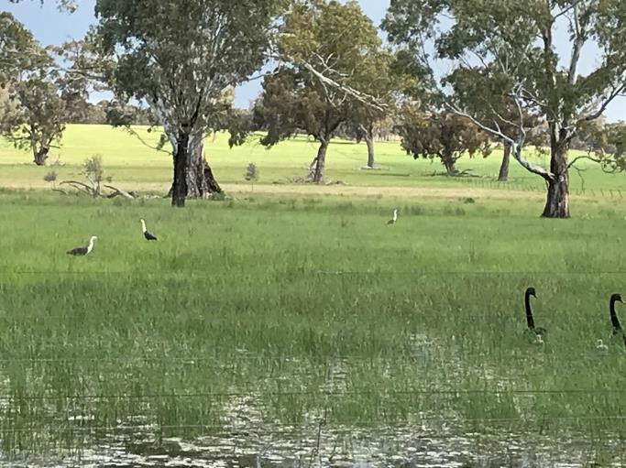
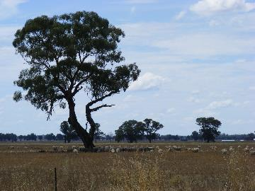
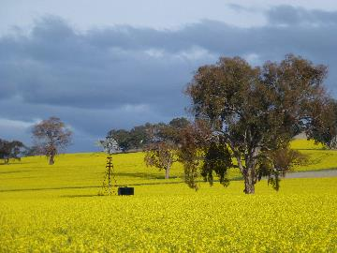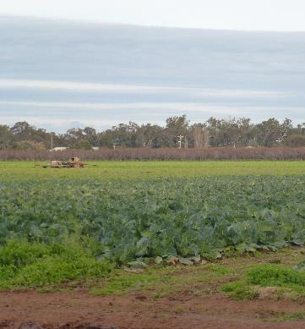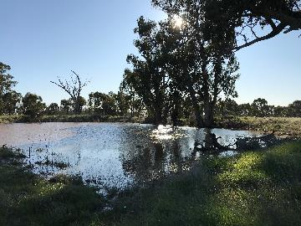

Jim Radford from LaTrobe University will talk about the benefits of biodiversity for agriculture.

Date: Tuesday 20th October 2020

Meeting place: Online
Click on the link below to register your attendance for the workshop.

Fill out form

Once you register for the workshop a link will be sent to your email address. In the email there will be a link that will take you to the workshop on the day. You do not have to download anything to attend this workshop.

Time: 9.30am start, try to log in 5mins prior to the start of the workshop.

If you have a query regarding this workshop contact

Karen Brisbane - Bullock

karenb@gbcma.vic.gov.au

Jim will present case studies and examples of research from Australia that show the benefits of biodiversity to agriculture. Examples will be drawn from a variety of farming systems with a focus on ecosystem services that benefit agricultural production. Jim will also cover what you can do to improve biodiversity on your farm.

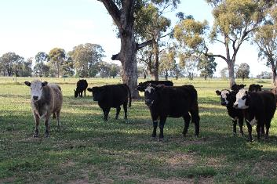







For more information contact us on:
Tel: (03) 5822 7700
www.gbcma.vic.gov.au

You can also follow us on:
This project is supported by the Goulburn Broken CMA through funding from the Australian Government’s National Landcare Program.
For more information contact us on:
Tel: (03) 5820 1100
www.gbcma.vic.gov.au

You can also follow us on:

